Parth Babbar

ATM

Introduction:
Automated Teller Machines (ATMs) are electronic banking facilities that allow consumers to do basic activities such as cash withdrawals, deposits, balance inquiries, and fund transfers without the need for human tellers. These machines have become a common component of the financial scene in the United States, allowing 24-hour access to banking services.
History & Evolution:
- 1969: Chemical Bank established the first ATM in the United States, in Rockville Centre, New York. This ATM only dispensed cash.
- 1970s: The introduction of ATMs capable of accepting both deposits and withdrawals.
- 1980s-1990s: Rapid expansion and acceptance of ATMs across the country, fuelled by technology breakthroughs and rising customer demand for convenience.
- 2000s: The introduction of sophisticated features include check and cash deposits, mini statements, and bill payments.
- 2010s: The introduction of smart ATMs that provide a variety of services such as mobile phone top-ups and ticket purchases.
- 2020s: Integrating contactless technologies and biometric authentication to improve security and user experience.
Current State:
- Total Number: As of 2023, there are roughly 451,500 ATMs in the US.
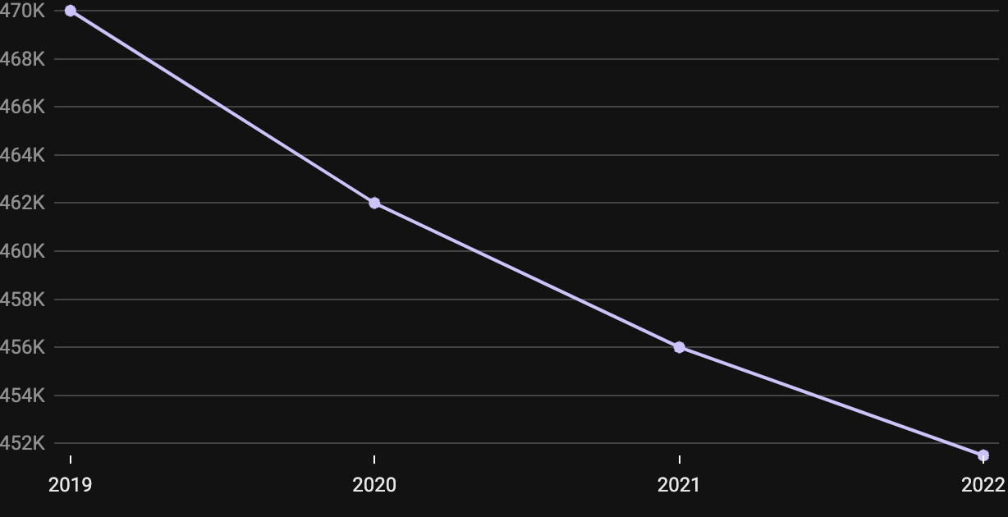
- Ownership: ATMs are owned by banks, independent service operators (ISOs), and third-party vendors.
- Location: Found in bank branches, retail businesses, airports, petrol stations, and other public areas.
Types:
- Bank ATMs: Located in bank branches and operated by banks, they provide a comprehensive range of financial services.
- Off-site ATMs: Located in retail outlets, airports, and other public areas, these machines primarily provide basic services like cash withdrawals and balance inquiries.
- White-label ATMs: Owned by non-bank organizations yet providing banking services to consumers from several banks.
- Smart ATMs: Advanced ATMs that provide extra services such as cash and check deposits, bill payments, and ticket purchases.
- Mobile ATMs: Temporary ATMs set up at events and festivals to allow easy access to cash.
Benefits:
- Convenience: ATMs offer 24-hour access to financial services, allowing clients to complete transactions outside of normal business hours.
- Geographical Reach: Automated teller machines (ATMs) enhance banks' reach to rural and underserved regions.
- Cost Effectiveness: For banks, ATMs are a more cost-effective alternative to branch operations for everyday transactions.
- Security: Modern ATMs provide extensive security mechanisms to prevent fraud and theft.
Challenges:
- Security risks: ATMs are susceptible to a variety of security risks, such as skimming, phishing, and physical attacks.
- Maintenance and Downtime: ATMs require regular maintenance to function properly, and downtime can be inconvenient for consumers.
- Technological Upgrades: Keeping ATMs up to speed with the latest technology may be expensive and complicated.
- Cash Management: Keeping ATMs fully filled with cash presents substantial logistical issues.
Solutions:
- Enhanced Security Measures: To improve ATM security, banks can install anti-skimming devices, utilize biometric verification, and use end-to-end encryption with real-time monitoring to prevent unauthorized access and detect fraudulent activity.
- Improved Maintenance Protocols: To increase ATM dependability, banks can employ predictive maintenance technologies to identify and solve problems before they create downtime. Implementing remote monitoring systems enables faster reaction times to maintenance requests, assuring ongoing and efficient functioning.
- Technological Upgrades: Regularly upgrading ATM software enables compatibility with new financial technology while also improving security. Upgrading ATMs to accept contactless transactions can increase both consumer convenience and security.
- Efficient Cash Management: Regularly upgrading ATM software improves compatibility with new financial technology and increases security. Upgrading ATMs to accept contactless transactions can increase both consumer convenience and security.
Future Outlook:
- Integration with Digital Banking: Integrating ATMs with digital banking platforms provides a more consistent consumer experience.
- Enhanced User Interfaces: Replacing ATMs with touch displays and user-friendly interfaces increases accessibility and usability.
- AI and Machine Learning: Using AI and machine learning improves fraud detection and personalizes services for users.
Usage Trends:
- Decline in Cash Transactions: As digital payments have grown in popularity, cash transactions have steadily decreased. However, cash remains a popular method of payment, particularly for minor purchases.
- Deposit ATMs: There is an increase in demand for deposit-taking ATMs, which allow users to deposit cash and checks without having to visit a bank.
- Increased Security: Use of EMV chip technology, anti-skimming devices, and biometric authentication to strengthen security.
- Mobile Integration: Use mobile banking apps to pre-stage transactions, resulting in faster and more convenient ATM encounters.
Statistics:
- An ATM in the United States does roughly 300 transactions per day on average, accounting for over 10 billion ATM transactions nationally each year. This large volume highlights the important role that ATMs play in providing clients with convenient financial services.
- The typical yearly cost of operating an ATM runs between $3,000 and $5,000, which includes maintenance, cash replenishment, and network costs.
- 60% of Americans aged 25-34, and 51% of those aged 35-49, withdraw $40.00 eight to ten times every month.
- The United States has one of the world's greatest ATM concentrations, with over 1,400 ATMs per million people.
- ATM cash withdrawals fell at a rate of 10.1% each year, reaching 3.7 billion in 2021. ATM cash withdrawals fell in value as well, albeit at a slower rate, with the average value rising from $156 in 2018 to $198 in 2021.
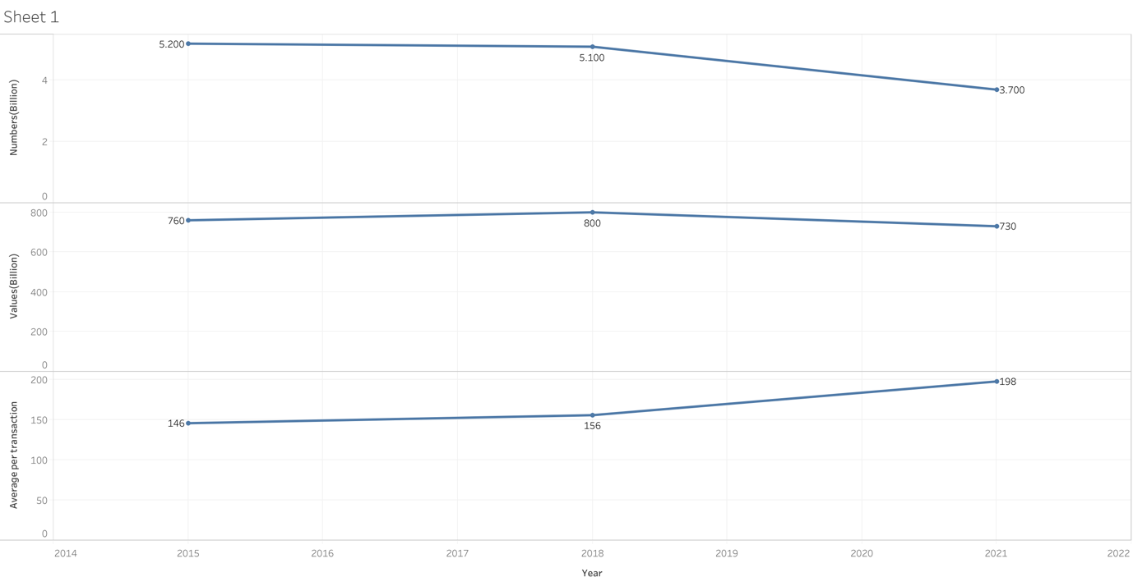
Conclusion:
ATMs remain an important part of the US financial system, offering key services to millions of clients every day. While they confront several problems, technological improvements and proactive steps may solve these concerns, ensuring that ATMs continue to provide efficient and safe financial alternatives. The continual evolution of ATMs promises to provide even better convenience and security to consumers in the future.

